Assignment No:9

Aim:Create an application, push to GitHub/GitLab repository. Use GitHub/GitLab, Maven,

Tomcat with Jenkins. Automate Deployment of the application to a container (Tomcat).

Step 1:Open Jenkins in web-browser, click on manage jenkins then select Global Tool Configuration.

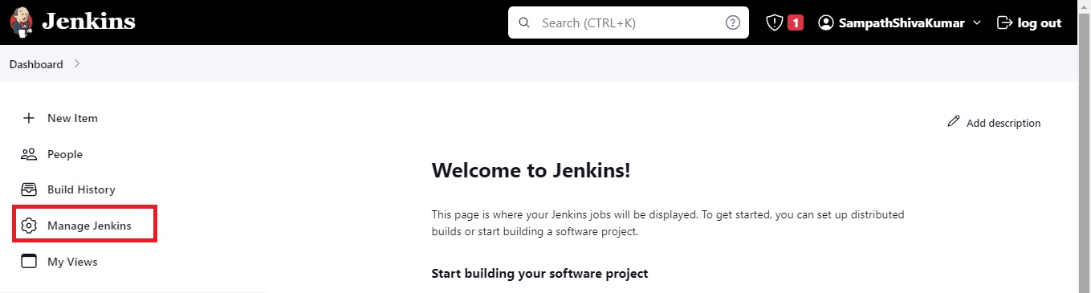

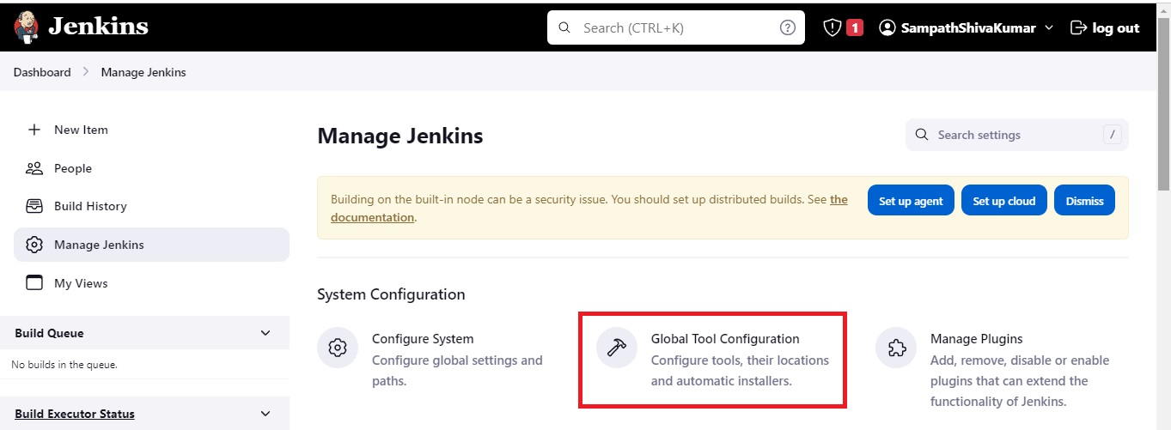

Step 2: In Git installations click Add git then select git.

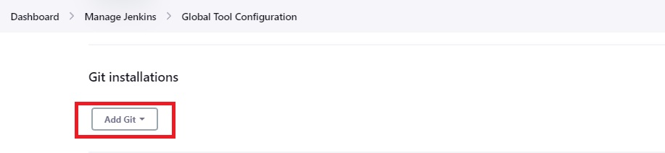

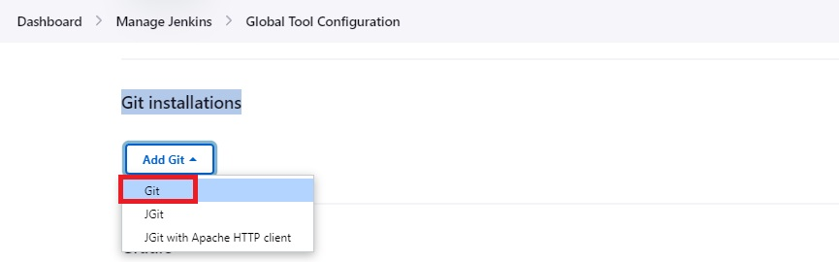

Step 3: Enter Name and Path to Git executable as below then click apply and save.

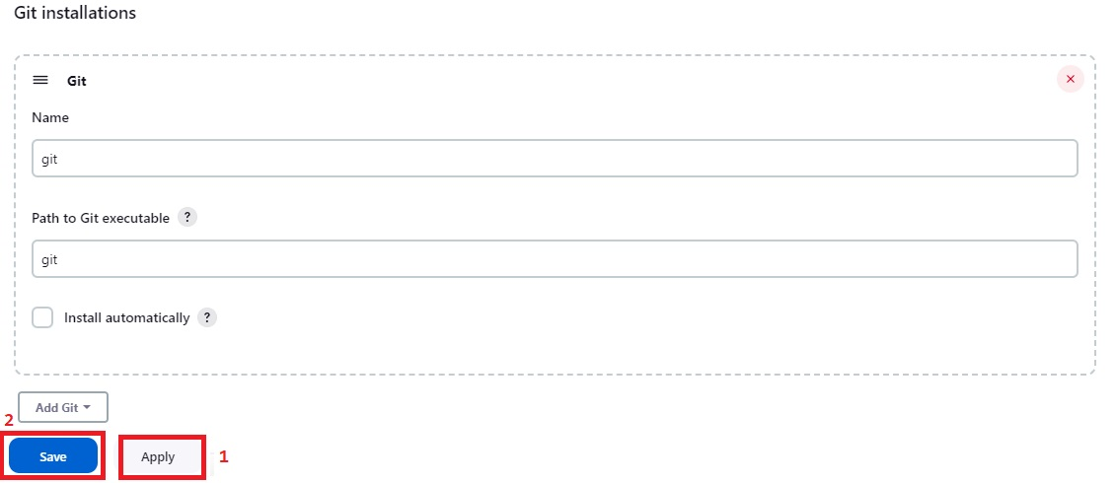

Now go to Jenkins Dashboard select Manage Jenkins then click on Global Tool Configuration.



In Maven installations click Add Maven and give name and select Install automatically then Appy and Save.

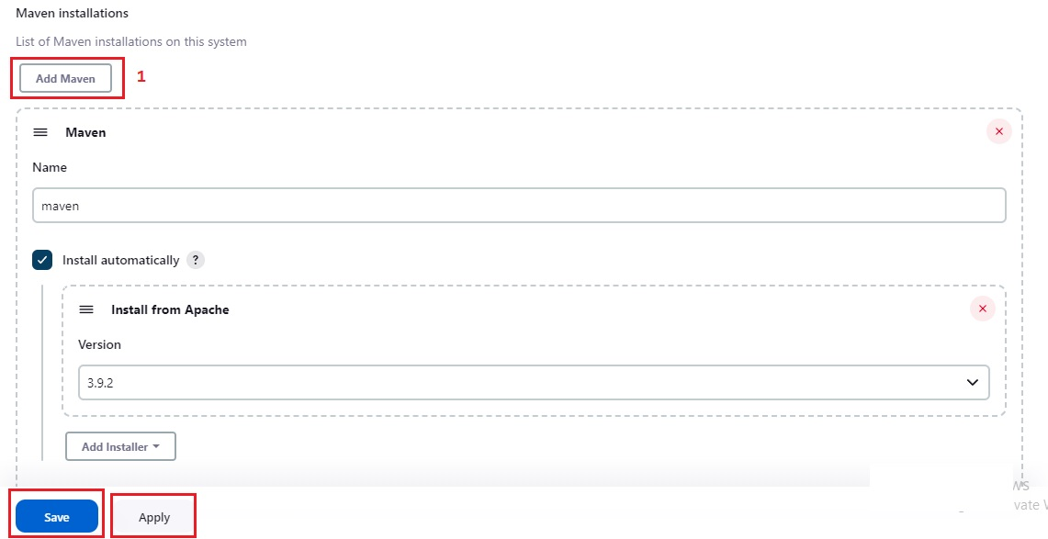

Install Deploy to container Plugin.

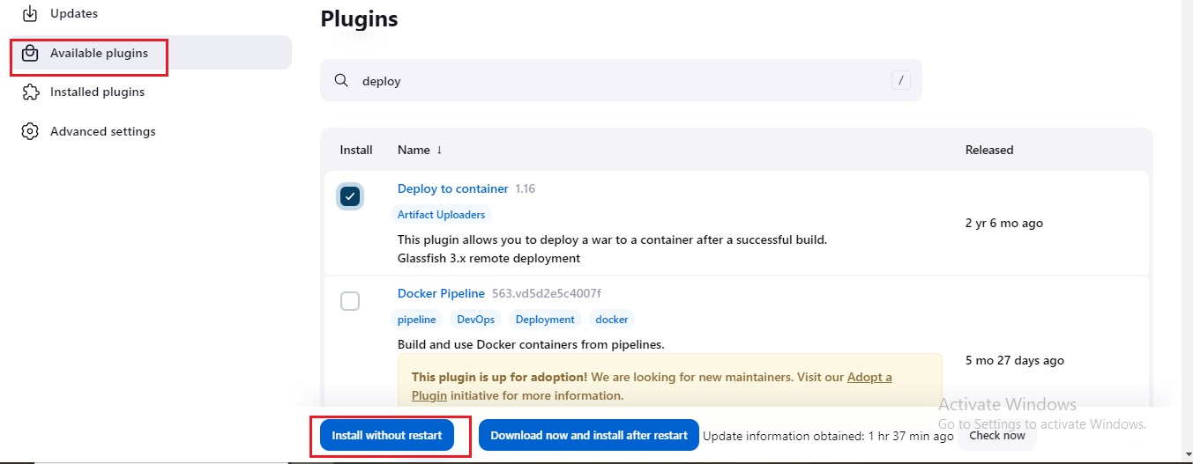

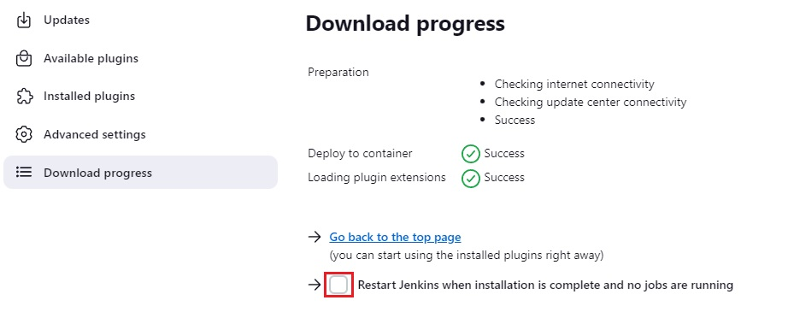

Go to Manage Jenkins and Click on Credentials.

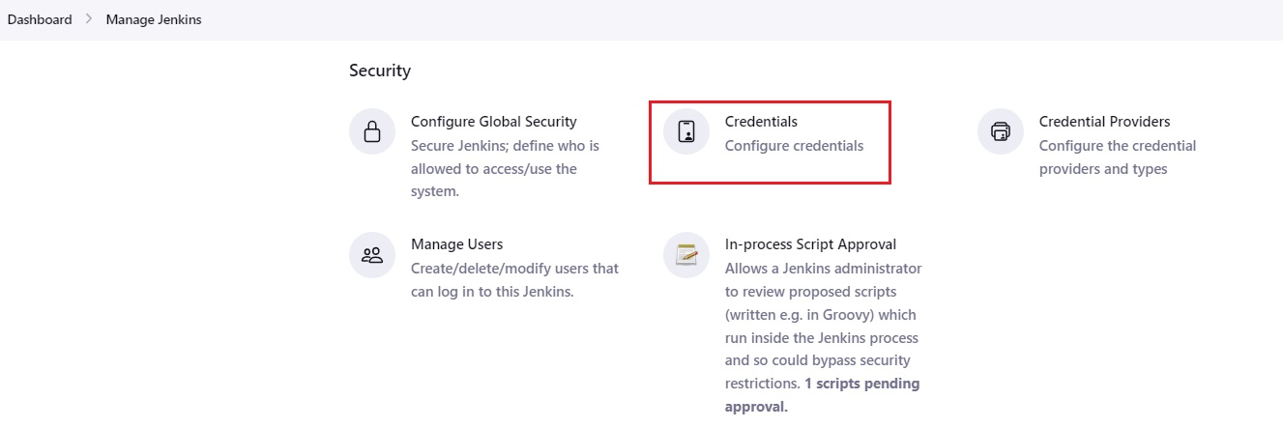

Select System

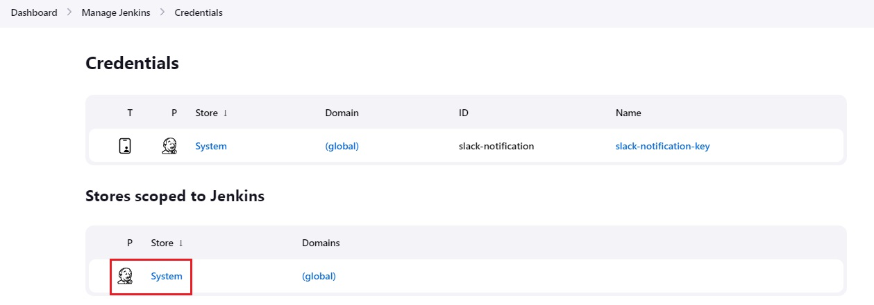

Select Global credentials

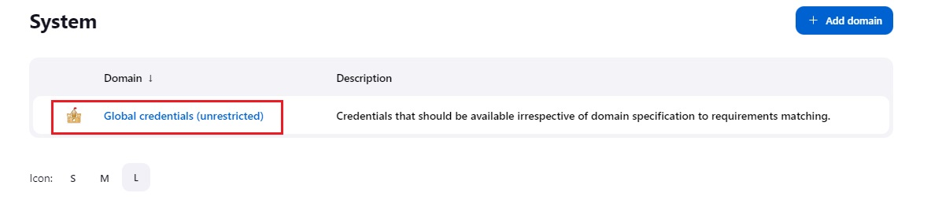

Select Add Credentials.

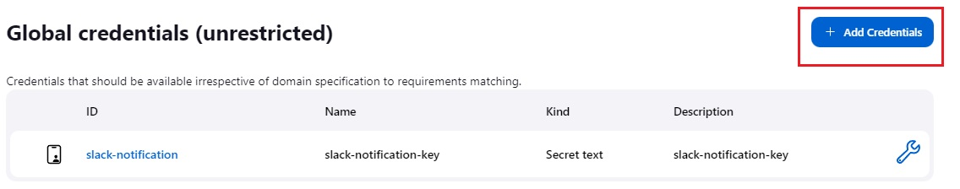

Enter username and password.

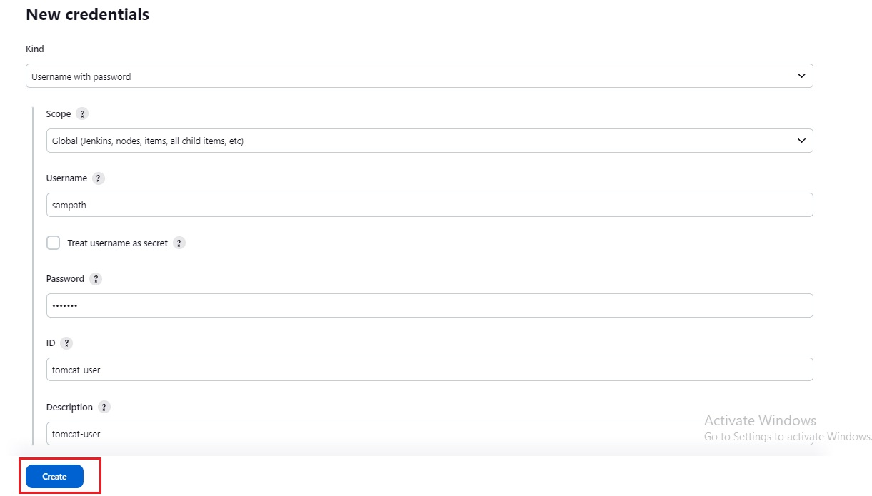

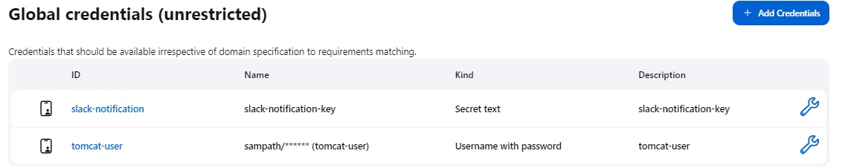

Now lets create a Jenkins job.

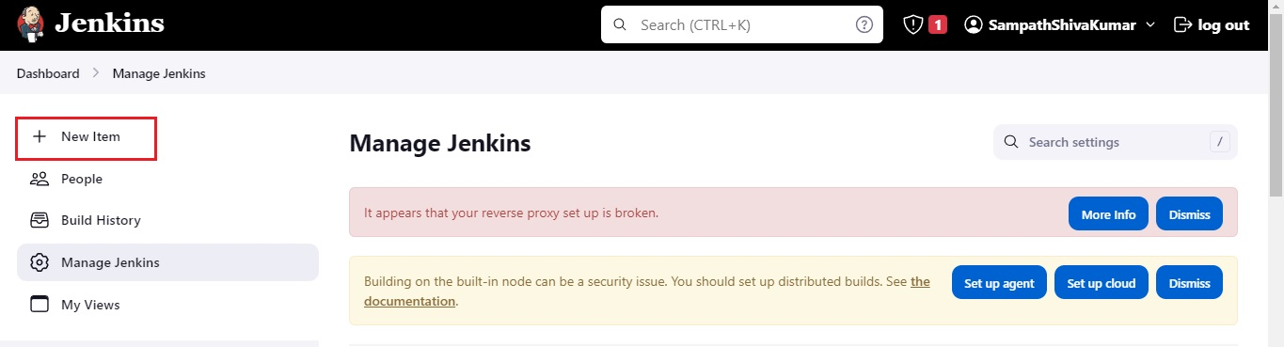

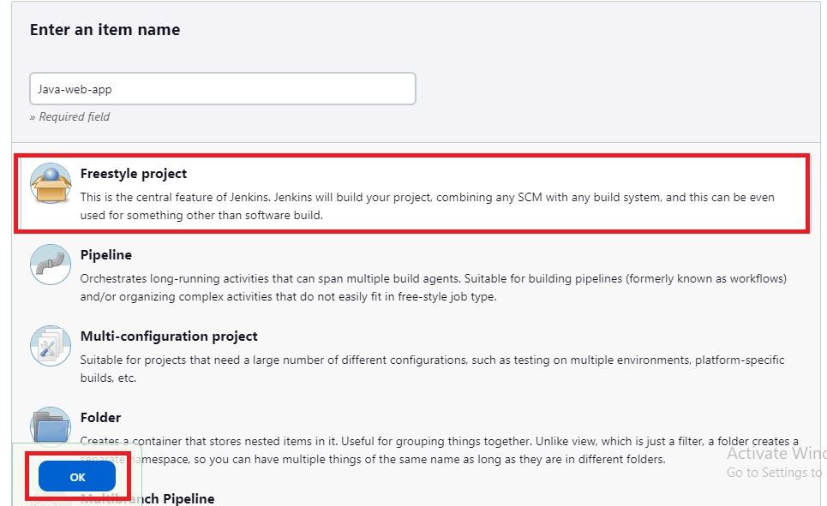

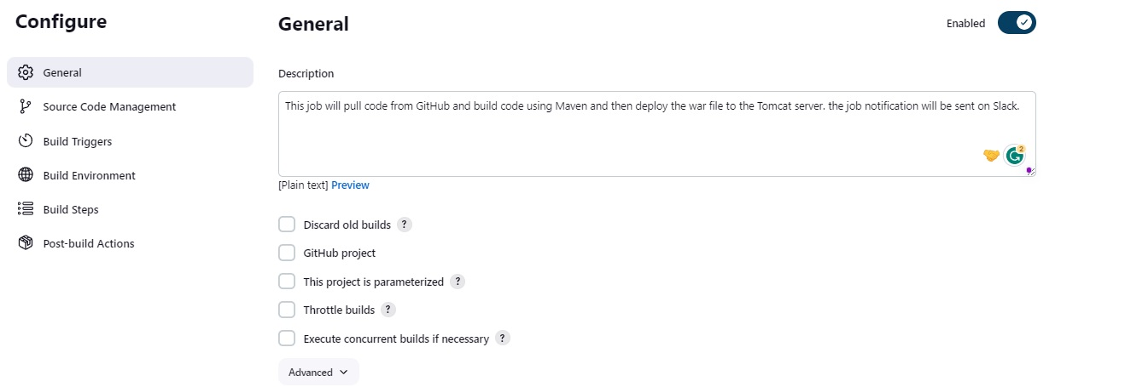

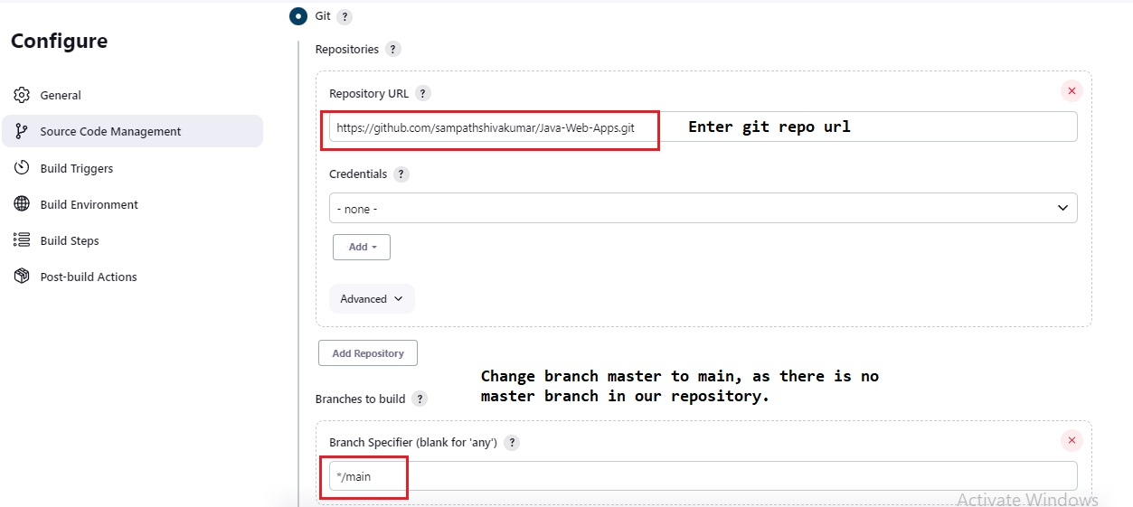

Provide Build details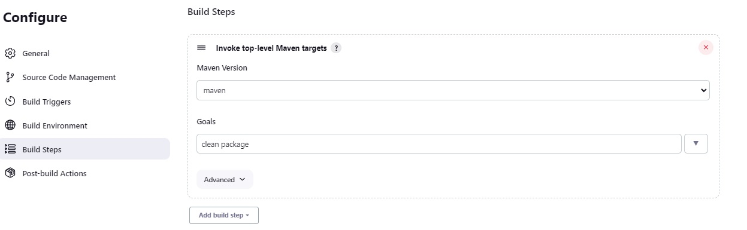

In Post-build Actions click Add Post-build Actions and Select Slack Notification and select following and click apply and save.

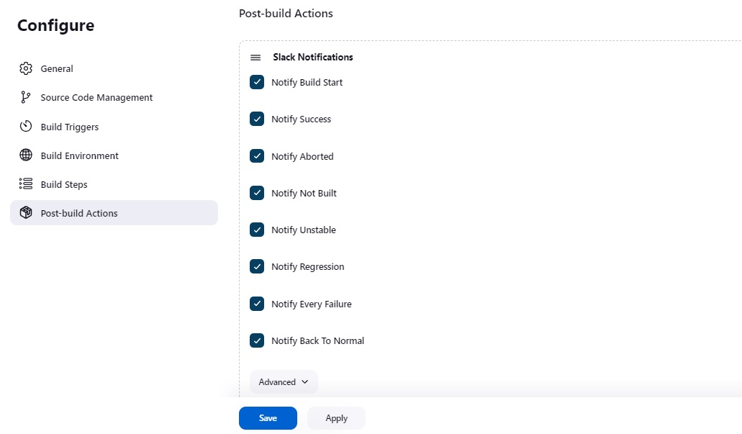

In Post-build Actions click Add Post-build Actions and Select Deploy war/ear to container

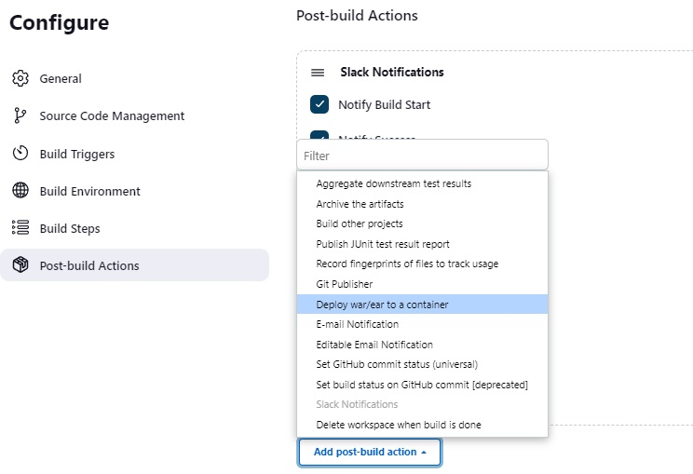

Enter the details as following then click on apply and save.

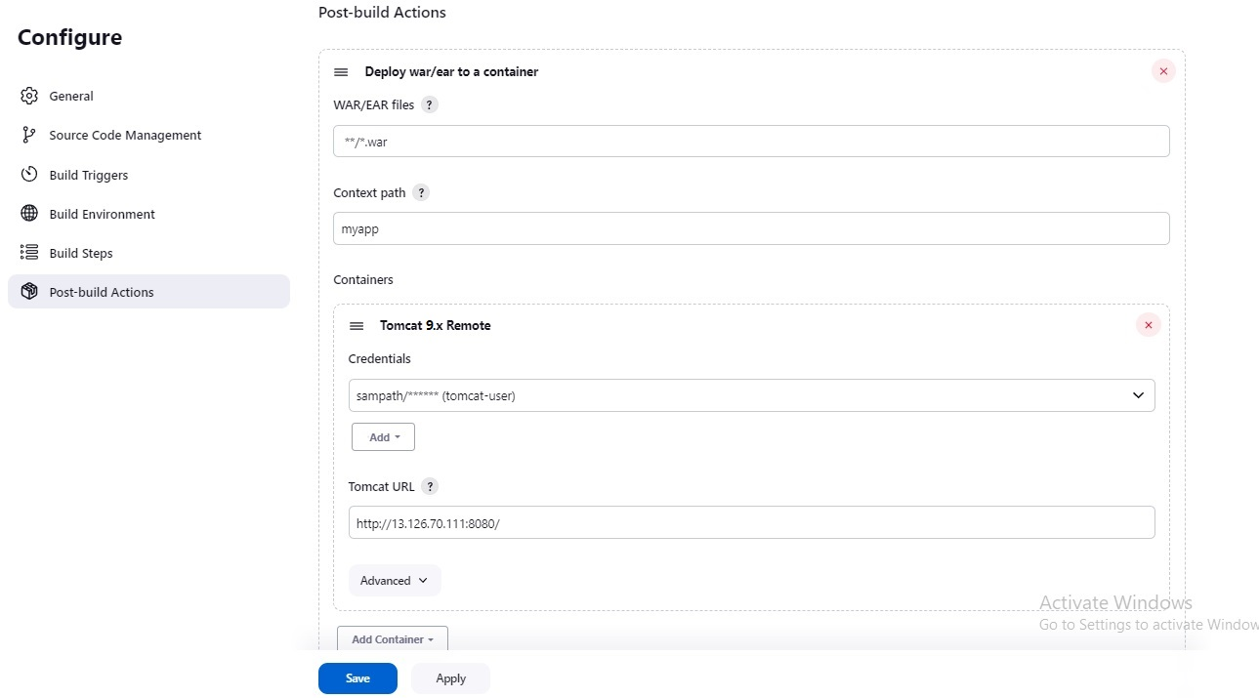

Now Click Build Now

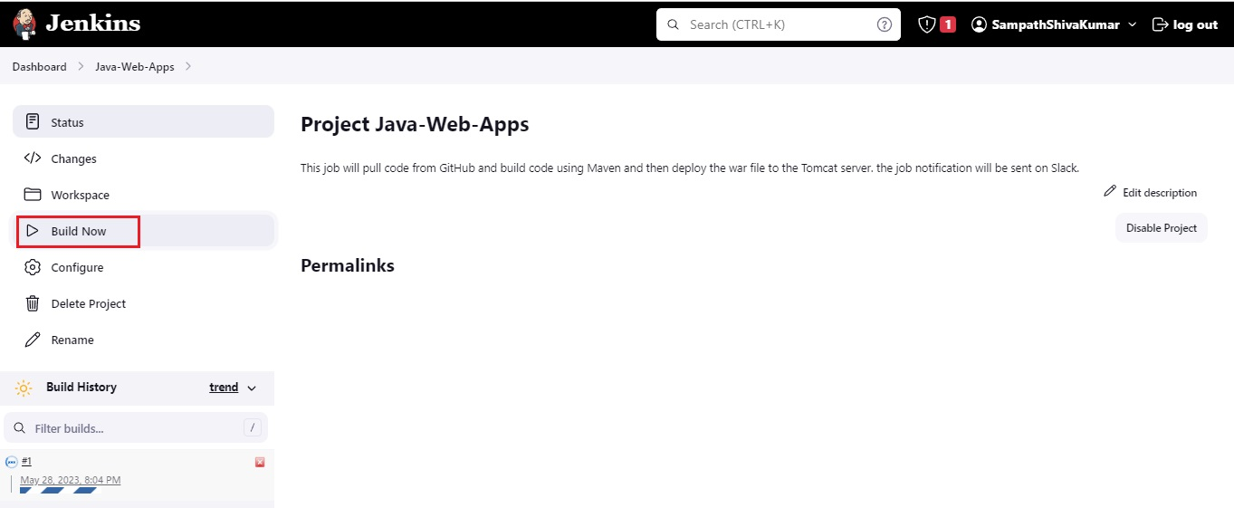

Build Successfull

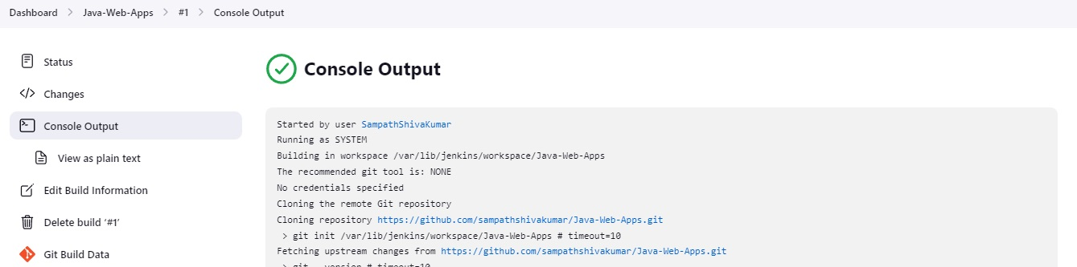

Slack Notifications.

